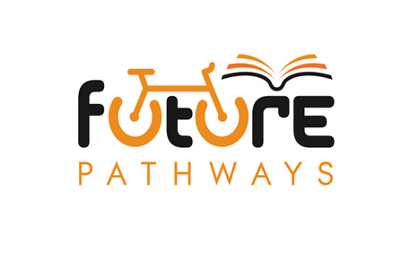

FUTURE PATHWAYS
Curriculum Policy

Date Policy Last Reviewed: November 2022
Date of next Review: November 2023

Future Pathways Curriculum Policy
Our Vision
At Future Pathways we strive to provide an outstanding, bespoke provision through delivering a person-centred curriculum to support positive behaviour, engagement enjoyment and motivation.
Our Ethos
Supporting students in overcoming barriers to learning and life. At Future Pathways we nurture all individuals in their journey to achieve their full and unique potential. We are committed to developing a safe and stimulating learning environment that enables our students to become responsible citizens and lifelong learners. We welcome students from all backgrounds and value their different experiences, interests and strengths, which influence the way they learn and develop as people. We work closely with Schools and Local Authorities to support students to re-engage and achieve.
Intent
The Future Pathways curriculum is individualised, , recognising the complex social and emotional needs of our pupils. The curriculum enables pupils to overcome barriers, re-engage in learning and develop skills required to successfully integrated into the community. The curriculum supports pupils in gaining cumulatively sufficient knowledge and skills to progress back into mainstream school or support their chosen pathway at post 16.
The Future Pathways curriculum has been developed to meet the needs of our pupils and has been designed with them in mind. We believe that all pupils have the right to learn at Future Pathways, despite any barriers to learning they may have or had in the past. Very often pupils have low self-esteem, and many are not working at age-appropriate levels. This may be because of underlying behavioural, social emotional problems, SEN, or medical reasons. Pupils in the main have not had a positive experience of education or school. We aim to offer a personalised experience based on individual need, interests and academic potential but provide additional care and support needed around each young person to enable them to thrive. We work Together, to Engage young people, enabling them to Enjoy activities and Motivate them for the future.
Our curriculum will encourage pupils to develop communication skills, perseverance, co-operation and team working , and life skills. The curriculum will provide our pupils with a range of experiences, building cultural capital; inspiring and enabling them to begin to understand the importance of learning and to begin learning again enabling them to make a lasting and positive contribution to future societies.
The quality of education provided aims to improve pupils’ knowledge, skills, and abilities, cultivating the confidence to apply and build on these as well as supporting pupils to have the levels of attainment required for the next stage of their education, training or employment.
Implementation
Our curriculum is individualised and set to meet the needs of individual pupils. We have established a curriculum meets the specific needs of each individual pupil. Pupils can study a range of subjects at different levels designed to suit their individual need. We work closely with schools to ensure continuity of progress and positive academic outcomes.
SMART targets focused on outcomes are set regularly and monitored through daily plans and reports. Our Enrichment Programme of visits, trips and enterprise allows pupils greater opportunity to find and develop their individual interests and talents. The curriculum promotes a sense of moral and social responsibility through a range of spiritual, moral, social and cultural opportunities, delivered through our PSHCE, Personal Development and Enrichment programmes as well as a focus on personal resilience and wellbeing.
Students are able to access the AQA unit award scheme, ASDAN short courses and GCSE level work as directed by their school. Our dedicated team of Academic mentors and student support mentors will ensure the best possible outcomes for each student.
Impact
Our pupils develop resilience and confidence and learn not to ‘give up’. We evaluate the needs of each pupil and creates the curriculum that supports their learning requirement. Pupils have the confidence to achieve at a pace and level that meets their needs. The Future Pathways curriculum helps foster a strength of character and resilience that will help pupils to cope with choices and overcome challenges they are likely to encounter in life. Our curriculum helps our pupils to mature and find the right pathway for them to be a success, allowing them to become life-long learners, good role models and well-rounded individual in all aspects of their lives.

